NOTES

Chapter no. 1:

Section no | Topic
1.1 | Basic Concept
Notes | An organization engaged in some commercial activity or business with the motive of earning profit is known as a business enterprise. If an individual or a group of individuals plans to start a new business or expand its existing business, selecting the right form of business organization is essential for them. There are five different forms of business organization from which one can select the best option for them. These are Sole Proprietorship, Joint Hindu Family Business, Partnership, Cooperative Societies and Joint Stock Companies. For selecting the most appropriate form of business organization, one has to weigh every merit and demerit of each form of an organization against their requirements  Forms of Business Organization  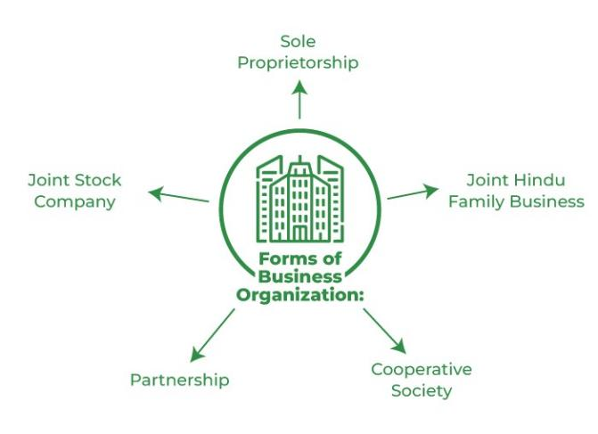  Sole Proprietorship  A popular form of business organization in which the business is owned, managed, and  controlled by an individual is known as a sole proprietorship. This individual is the recipient of every profit and loss of the business and bears every risk coming to the business. Here, the word sole means only and proprietor means owner; hence, the only owner of the business. Usually, businesses with personalized services like hair salons, beauty parlours, retail shops, etc., run under sole proprietorship. In this form of business, the owner is not separate from the business; hence, no separate legal entity. Besides, the owner does not have to perform any legal formality and can start the business whenever they want.

Joint Hindu Family Business
A form of business organization found only in India in which the business is owned and carried on by the HUF(Hindu Undivided Family) members is known as Joint Hindu Family Business. It is one of the oldest forms of business organization in India. This form is governed by the ‘Hindu Law’. The eldest member and head of the family, also known as “Karta,” controls the business. Membership in this form of business organization is based on the birth in a specific family. The three successive members of the family can be the members of the business. Every member of the business have equal right and ownership over their ancestor’s property, and these members are known as ‘copercenters.’ The two conditions for the existence of a Joint Hindu Family Business are: there must be some ancestral property, and a minimum of two male members must be in the family.
Partnership
The most crucial disadvantage of a sole proprietorship is the lack of enough financing in the business, which is resolved in this form of business organization. According to the Indian Partnership Act, 1932, a partnership is a form of business organization in which there is a relation between two or more people with an agreement to share the firm’s profits carried on by every partner or any one of the partners acting for all. It solves the need to acquire greater capital investment, risk-sharing, and a variety of skills in the business, which is not available in Sole Proprietorship and Joint Hindu Family Business. The minimum number of partners required in a partnership firm is two. There are different types of partners and partnerships in this form of business organization. Cooperative Society A voluntary association of people joining together with the main objective of members’ welfare is known as a cooperative society. As the name suggests, people in this form of business organization work together and with other people for the accomplishment of a common purpose. The power to make decisions in a Cooperative Society is in the hands of an elected managing committee. The Cooperative Societies Act, of 1912 states that it is compulsory to register a Cooperative Society. Setting up and forming this form of business organization requires the consent of at-least ten adult people. The capital for the business is raised by its members through the issue of shares. After the registration of the Cooperative Society is complete, it acquires a separate legal identity in the market. There are different types of cooperative societies categorized on the basis of their nature of operations.
Joint Stock Company
An association of different individuals formed to carry out business activities is known as a joint stock company. This form of organization has an independent legal status from its members. Basically, a joint stock company is an artificial individual with a separate legal entity, common seal and perpetual succession. The Joint Stock Company form of organization is governed by the Companies Act, 2013. The shareholders of the company are its owners; however, the Board of Directors is elected by the shareholders and is the chief managing body of the company. Usually, the shareholders or the owners of the company have indirect control over its operations. A company can be either private or a public company.

1.2 | Importance of Accounting
Notes | - Keeps a record of business transactions  Accounting is important as it keeps a systematic record of the organization’s financial information. Up-to-date records help users compare current financial information to historical data. With full, consistent, and accurate records, it enables users to assess the performance of a company over a period of time.  - Facilitates decision-making for management  Accounting is especially important for internal users of the organization. Internal users may include the people that plan, organize, and run the organization. The management team needs accounting in making important decisions. Business decisions may range from deciding to pursue geographical expansion to improving operational efficiency.  - Communicates results

Accounting helps to communicate company results to various users. Investors, lenders, and other creditors are the primary external users of accounting information. Investors may be deciding to buy shares in the company, while lenders need to analyze their risk in deciding to lend. It is important for companies to establish credibility with these external users through relevant and reliable accounting information.
4. Meets legal requirements
Proper accounting helps organizations ensure accurate reporting of financial assets and liabilities. Tax authorities, such as the U.S. Internal Revenue Service (IRS) and the Canada Revenue Agency (CRA), use standardized accounting financial statements to assess a company’s declared gross revenue and net income. The system of accounting helps to ensure that a company’s financial statements are legally and accurately reported.

1.3 | Basic Accounting Terms
Notes | In order to understand the subject matter clearly, one must grasp the following common expressions always used in business accounting. The aim here is to enable the student to understand with these often used concepts before we embark on accounting procedures and rules.  Transaction  : It means an event or a business activity which involves exchange of money or money’s worth between parties. The event can be measured in terms of money and changes the financial position of a person e.g. purchase of goods would involve receiving material and making payment or creating an obligation to pay to the supplier at a future date. Transaction could be a cash transaction or credit transaction. When the parties settle the transaction immediately by making payment in cash or by cheque, it is called a cash transaction. In credit transaction, the payment is settled at a future date as per agreement between the parties.  Profit:  The excess of Revenue Income over expense is called profit. It could be calculated for each transaction or for business as a whole.  Loss: The excess of expense over income is called loss. It could be calculated for each transaction or for business as a whole.  Asset: Asset is a resource owned by the business with the purpose of using it for generating future profits. Assets can be Tangible and Intangible. Tangible Assets are the Capital assets which have some physical existence. e.g. Plant and Machinery, Furniture and Fittings, Land and Buildings, Books, Computers, Vehicles, etc. The capital assets which have no physical existence and whose value is limited by the rights and anticipated benefits that possession confers upon the owner are known as intangible Assets. e.g. Goodwill, Patents, Trade-marks, Copyrights ,Brand Equity, Designs, Intellectual Property, etc.  Liability : It is an obligation of financial nature to be settled at a future date. It represents amount of money that the business owes to the other parties. E.g. when goods are bought on credit, the firm will create an obligation to pay to the supplier the price of goods on an agreed future date or when a loan is taken from bank, an obligation to pay interest and principal amount is created.  Capital : It is amount invested in the business by its owners. It may be in the form of cash ,goods ,or any other asset which the proprietor or partners of business invest in the business activity. From business point of view, capital of owners is a liability which is to be settled only in the event of closure or transfer of the business. Hence, it is not classified as a normal liability. For corporate bodies, capital is normally represented as share capital.  Debtor: The sum total or aggregate of the amounts which the customer owe to the business for purchasing goods on credit or services rendered or in respect of other contractual obligations, is known as Sundry Debtors or Trade Debtors, or Trade Payable, or Book-Debts or Debtors. In other words, Debtors are those persons from whom a business has to recover money on account of goods sold or service rendered on credit.  Creditor: A creditor is a person to whom the business owes money or money’s worth. e.g. money payable to supplier of goods or provider of service. Creditors are generally

classified Current Liabilities
Capital Expenditure : This represents expenditure incurred for the purpose of acquiring a fixed asset which is intended to be used over long term for earning profits there from. e. g. amount paid to buy a computer for office use is a capital expenditure. At times expenditure may be incurred for enhancing the production capacity of the machine. This also will be a capital expenditure. Capital expenditure forms part of the Balance Sheet.
Revenue expenditure
: This represents expenditure incurred to earn revenue of the
current period.The benefits of revenue expenses get exhausted in the year of the incurren ce. e.g. repairs, insurance, salary & wages to employees, travel etc. The revenue expenditure results in reduction in profit or surplus. It forms part of the Income statement. Business usually prepares 3 reports.
1.A statement of financial position referred to as balance sheet
2. Income statement
3.Statement of cash flows. In this module, we can just concentrate on the income statement and Balance sheet.
Balance Sheet : It is the statement of financial position of the business entity on a particular date. It lists all assets, liabilities and capital. It is important to note that this statement exhibits the state of affairs of the business as on a particular date only. It describes what the business owns and what the business owes to outsiders (this denotes liabilities) and to the owners (this denotes capital). It is prepared after incorporating the resulting profit/losses of Income statement.
Profit and Loss Account or Income Statement: This account shows the revenue earned by the business and the expenses incurred by the business to earn that revenue. This is prepared usually for a particular accounting period, which could be a month, quarter, a half year or a year. The net result of the Profit and Loss Account will show profit earned or loss suffered by the business entity.

1.4 | Basic Concepts
Notes | These are the basic ideas or assumptions under the theory base of accounting that provide certain working rules for the accounting activities of an organization. There are 13 important basic accounting concepts that are to be followed by companies to prepare true and fair financial statements.  Business Entity Concept  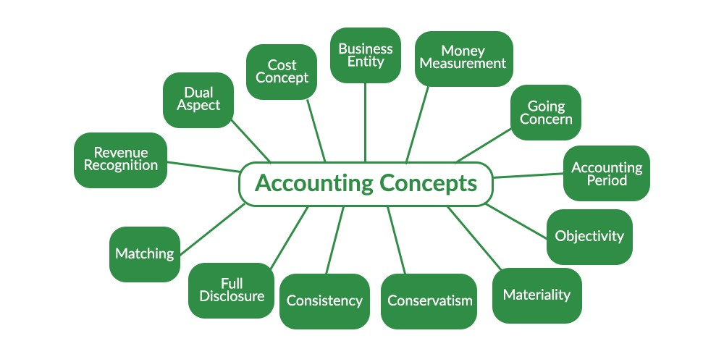  The business entity concept states that the business enterprise is separate from its owner. In simple terms, for accounting purposes, the business and its owners are treated separately. If an owner invests money in the business, it will be treated as a liability for the business. However, if the owner takes out some money from the business for personal use, it will be considered drawings. Therefore, assets and liabilities of a business are the business’s assets and liabilities, not the owner’s. Hence, the books of accounts include the accounting records from the point of view of the business instead of the owner. For

example, the amount of 1,00,000 in ABC Ltd. by its owner Raj will be considered a liability to the business. The business entity concept applies to partnerships, companies, sole proprietorships, small enterprises, and large enterprises.
Money Measurement Concept
The money measurement concept says that a business should record only those transactions which can be expressed in monetary terms. It means that transactions like purchase and sale of goods, rent payment, expenses payment, earning of revenue, etc., will be recorded in the books of accounts of the firm. However, transactions or happenings, like the research department’s creativity, machinery breakdown, etc., will not be recorded in the books of accounts of the firm. Besides, the records of transactions of a firm should not be recorded in physical units, such as 3 acre land, 20 computers, 40 chairs, etc., instead, they should be recorded in monetary terms, such as ₹ 13 lakh for land, ₹ 15 lakh for computers, and ₹2 lakh for chairs, etc., in the books of accounts.
However, there are two drawbacks of this concept in accounting. Firstly, according to this concept, the accounting of a business is limited to the recording of information that can be expressed in a monetary unit, but does not involve or record essential information that cannot be expressed in monetary units. Secondly, the concept has the limitations of the monetary unit itself.
Going Concern Concept
The going concern concept assumes that an organization would continue its business operations indefinitely. It means that it is assumed that the business will run for a long period of time, and will not liquidate in the foreseeable future. It is one of the most important assumptions or concepts of accounting. It is because the going concern concept provides the firm with the basis to show its assets’ value in the balance sheet.
For example, if an organization purchases machinery for ₹1,00,000, it would not be fair to show the full amount of the machinery in one year, as the company will be getting service or production with the help of machinery for several years. Therefore, the going concern concept by assuming that the business will not liquidate in the foreseeable future states that the firm should record the machinery’s value for its estimated life span. Let’s say, the life span of the said machinery is 10 years. Now, the firm may charge ₹10,000 for 10 years from the profit and loss account.
Accounting Period Concept
The accounting period concept defines the time span at the end of which an organization has to prepare its financial statements to determine whether they have earned profits or incurred losses during a specified time span. It also states the exact position of the firm’s assets and liabilities at the end of the specified time span. This information is used by different internal and external users of the organization for various purposes regularly. The financial statements are prepared regularly because it helps them in the decisionmaking process, and no firm can wait for long to know its results. The normal interval for the preparation of the financial statements is one year. This time interval of one year is known as the accounting period. According to the Companies Act, 2013 and the Income Tax Act, an organization has to prepare its income statements annually. However, in some cases, like the retirement of a partner between the accounting period, etc., the firm can prepare interim financial statements.
Cost Concept
The cost concept of accounting states that an organization should record all of its assets at their purchase price in the books of accounts. This amount also includes any transportation cost, acquisition cost, installation cost, and any other cost spent by the firm for making the asset ready to use. For example, Radha Ltd. purchased machinery for ₹60 lakh in July 2021. It has also spent a sum of ₹10,000 on transportation, ₹20,000 on its installation, and ₹15,000 on making it ready to use. The total amount at which the organization will record the value of machinery in the books of account would be ₹60,45,000.

Therefore, the cost concept or historical cost concept states that since the company is not going to sell the assets as per the going concern concept, there is no point in revaluing the assets and showing their current value. Besides, for practical reasons also, the accountants of an organization prefer to report the actual costs to its market values. However, the asset amount listed in the books of accounts of the firm does not indicate the value at which it can sell the asset.
Dual Aspect or Duality Concept
The dual aspect or duality concept is the foundation of any business. The concept describes the basis of recording business transactions in the books of accounts. According to the concept, every transaction of the business has a two-fold effect. Hence, it should record every transaction in two places. In simple words, two accounts will be affected by a single transaction. This concept can be expressed as the Accounting Equation:
Assets = Liabilities + Capital
The accounting equation states that the total of assets of an organization is always equal to the total of its owners’ and outsiders’ claims. These claims or equity of the firm’s owners is also known as Capital or Owner’s Equity, and the outsiders’ claims are known as Liabilities or Creditors’ Equity. For example, Rohan started a business by investing a sum of ₹1 crore. This amount will increase the cash (asset side) of the business, and will also increase its capital by the same amount, i.e., ₹1 crore. Therefore, the effect of the transaction will be shown in two accounts, i.e., cash and capital account. The dual concept forms the base of the Double Entry System of Accounting.
Revenue Recognition Concept
The revenue recognition concept, also known as the realisation concept, as the name suggests, defines that an organization should record its revenue from business only when it is realised, not when the firm has received the cash. Let us understand the concept with the help of an example. Suppose a client pays ₹5,000 in advance for a product. The company will not realise the amount of revenue until its work on the product is complete. Therefore, the firm will initially record the amount as a liability in the unearned revenue account. Once the product has shipped to the client, it will be transferred to the revenue account. Let us take another example of delayed payment. Suppose a company ships its goods amounting to ₹10,000 to its customer on the credit of 30 days. The company will realise the same as soon as the goods have been shipped even though it will receive the amount in the future.
Matching Concept
The matching concept states that an organization should recognize its expenses in the same financial year if the expense is related to the revenue of that year. In simple words, if a firm is earning revenue in an accounting period, even though it incurs the expenses related to that revenue in the next accounting year, the expense will be realized in the same accounting year when the revenue has been realized by the firm. For example, if a salesman sells goods worth ₹10,00,000 in February 2022 on a 6% commission made in May 2022, the commission expense of 6% will be charged in the accounting year in which the sales have been made, i.e., 2021-2022. A company should keep in mind that the matching concept should be followed only after the realisation concept has been fulfilled.
Full Disclosure Concept
As the name suggests, the full disclosure concept states that an organization should disclose all the facts regarding its financial performance. It is because the information mentioned in the financial statements is used by different internal and external users, like investors, banks, creditors, management, employees, financial institutions, etc., for making financial decisions. Hence, the concept says that all relevant and material facts or figures about an organisation must be disclosed in its financial statements. To fully ensure this concept, an organization has to prepare its Balance Sheet and Profit & Loss
Account based on the format provided by the Indian Companies Act 1956. Besides,

different regulatory bodies, like SEBI, also make it compulsory for companies to completely disclose the true and fair picture of their state of affairs and profitability.
Consistency Concept
The consistency concept states that there should be consistency or uniformity in the accounting practices and policies followed by an organization. It is because the accounting information provided by an organization through its financial statements would be beneficial only when it allows its users in making a comparison between the statements of different years or with statements of other firms. However, it does not mean that the organization cannot change its accounting policies when necessary. The firm can make required changes in its policies by properly indicating the probable effect of the changes on its financial results. For example, if a company’s management wants to compare the net profit of the current year with the previous year, it can do so only when the accounting policies followed by the company in both years are the same. For example, if a company has used the SLM depreciation method in the previous year and the WDV method of depreciation in the current year; it would not be able to compare the figures.
Conservatism Concept
The conservatism or prudence concept believes in playing safely, while recording the transactions in the book of accounts. According to this concept, an organization should adopt a conscious approach and should not record its profits until they are realised. However, it states that the organization should realise any loss even if the company has not incurred it yet, or if there is a slight possibility of loss to occurring in the future. No matter how pessimist attitude this concept shows, it is essential for an organization to deal with uncertainty and allows them to protect the interest of creditors against any unwanted distribution of its assets. For example, if an organization feels that a certain debtor will not pay the amount in the future, it should open a Provision for Doubtful Debts Account. Similarly, an organization should not record its increase in the market value of stock until it is sold.
Materiality Concept
The materiality concept suggests that an organization should focus on material facts only. In simple words, an organization should not waste its time on immaterial facts that do not help in determining its income for the period. In order to differentiate a fact as material or immaterial, one should consider its nature and the amount involved. Therefore, a fact will be considered material if the accountant believes that the information can influence the decisions of a user of the financial statements. For example, the original cost of stationery is insignificant to the users of financial statements. Hence they are not included in the closing stock of the statements and are shown under expenses. Similarly, suppose the company has incurred an expense on the marketing of the firm or its products. In that case, it will be shown in the financial statements as it is a material fact for the users and can change their decisions.
Objectivity Concept
The objectivity concept of accounting states that an organization should record transactions in an objective manner. It means that the recording should be free from any kind of biasness by accountants and other people. Objectivity in the recording of transactions is possible when the transactions of the firm are supported by verifiable vouchers or documents. The purpose of the objectivity concept is that it does not let the firm’s management and accountants’ opinions impact the financial statements and provide a false image. The concept can be helpful for an organization in creation of its goodwill. Besides, it warns the companies about the penalties if there is any sort of misinterpretation in the financial statements.

• Bahi Khata is a traditional Indian accounting system that has been used for centuries, especially by small businesses, traders, and shopkeepers. It literally

means "ledger account" and is used to record financial transactions in a handwritten format.
- The Ancient Indian or Mahajani Accounting System is a traditional method of bookkeeping that has been used in India for centuries, particularly by merchants, traders, and moneylenders. It is known for its unique style of writing numerals and maintaining accounts. The system has its roots in ancient Indian civilization and has influenced modern accounting practices.
- History and Evolution
Ancient Roots: The origins of the Indian accounting system can be traced back to the Indus Valley Civilization (around 3000 BCE), where evidence of record-keeping on clay tablets has been found. The system evolved over centuries, incorporating complex trade and financial activities of Indian merchants.
Vedic Period: During the Vedic period (1500–500 BCE), the concept of bookkeeping was mentioned in texts like the Arthashastra by Kautilya (Chanakya). It described methods for maintaining accounts of the state and private enterprises, including rules for balancing books and accounting for expenses.
Mahajani System: The Mahajani system, often called the Baniya or Shetty system in different parts of India, became prominent during the medieval period. It was used extensively by community-based traders and moneylenders (Mahajans or Baniyas). The system is characterized by a unique script called Lipi, which is a shorthand for writing numbers and transactions in the local languages.
Numerical Notation: The Mahajani system used distinct symbols for numbers, often in a vertical format, and special abbreviations to represent frequent transactions, like debts or payments. This numerical system was different from the standard Indo-Arabic numerals used today and required specialized knowledge to interpret.
Records and Ledgers: Transactions were recorded in various types of Bahi Khata (account books) such as:
Rojmel: Daily cash book.
Khatavahi: Ledger for recording individual accounts.
Jama-Namuna: Account of debts and credits.
Geographical Spread: The Mahajani system was not confined to a single region but adapted to different localities, with variations found in Gujarat, Rajasthan, Maharashtra, and parts of North and South India.
Impact of Colonial Period: During British rule, the Mahajani system continued to thrive in indigenous trade circles, but Western accounting practices gradually began to be adopted by businesses dealing with the colonial administration. This period saw the coexistence of traditional and modern systems of accounting.
Modern Transition: With the advent of modern education and accounting software, the use of the Mahajani system has declined. However, it is still practiced in some traditional business communities and regions, and has cultural and historical significance.

1.5 | Double entry concept and Classification of Account , Journal
Double Entry Concept
Meaning and Definition of Double Entry Book-Keeping:
Double Entry Book-keeping System is the most scientific method of recording all monetary transactions in the books of accounts. This system owes its origin to Italian

Merchant “LUCA D. BARGO PACIOLI” on 10th November 1494 and this day is celebrated as International Accounting Day. This system of Bookkeeping is based on the fact that there are two aspects of every business transactions. Every business transaction involves two persons or accounts or parties where in one is the receiver of the benefit and the other is the giver of the benefit. If something comes into the business, something goes out from the business. Recording of two aspects of monetary transactions in the Books of Account in terms of Debit (Dr.) and Credit (Cr.) is called as "Double Entry" System of Book-keeping. According to modern approach, every business transaction is concerned with Assets, Liabilities, Capital, Expenses and Income. Whenever there is an increase in assets and expenses it is debited and decrease in assets and expenses are credited.
Double Entry System is the most scientific method of recording all business transactions in the books of accounts. Under this system double or two fold effects of each transaction is recorded. According to Double Entry Book-keeping System, one account is to be debited and another account is to be credited with equal amount.
Every debit has an equal and corresponding credit of the same amount is the basic principle of Double Entry System.
Classification of Accounts

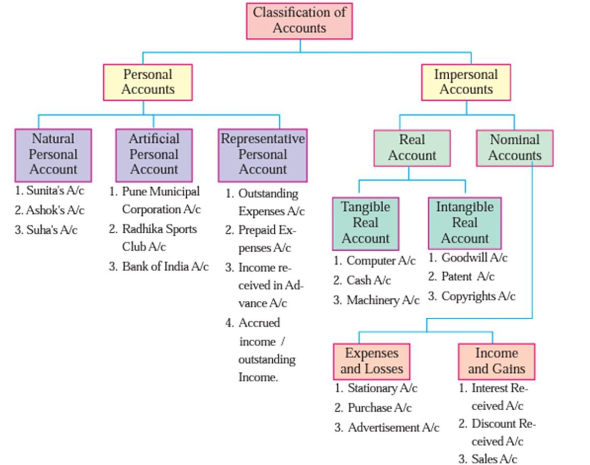

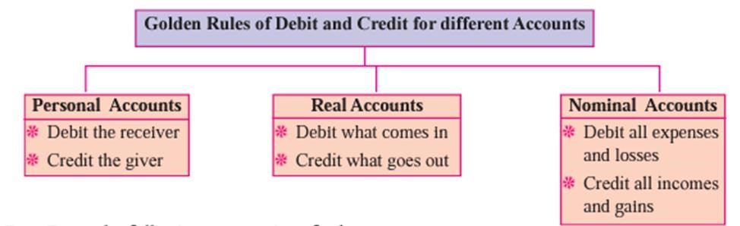
Journal
Introduction : Everyday businessmen performs large number of transactions. These transactions cannot be remembered at a glance. Therefore these transactions must be recorded in different types of books. He keeps different accounting records. The number of books depends upon the size and nature of business and volume of transactions but important books of accounts which must be maintained by every businessmen are Journal and Ledger. Journal is a book employed to classify or sort out transaction in a form convenient for their subsequent entries in Ledger Journal keeps record of daily financial transaction . It is also known as Book of Original Entry. When the Journal transactions are recorded in the Journal it becomes Journal entry .Journal entries consist of the name of debit and name of credit involved in the financial transaction with a brief narration. Journal is a book in which the business transactions are first recorded in a chronological order i.e. Date wise in the order in which they take place.
Meaning: The word “Journal” is derived from the French word “JOUR” which means a
“Day”. Therefore journal means a “daily record”. A journal contains a daily record of business transactions and hence it has been named so, as soon as a transaction takes place its debit and credit aspects are analyzed and first of all recorded chronologically i.e. In the order of their occurrence(taking place). Journal is a book of original entry or primary entry.
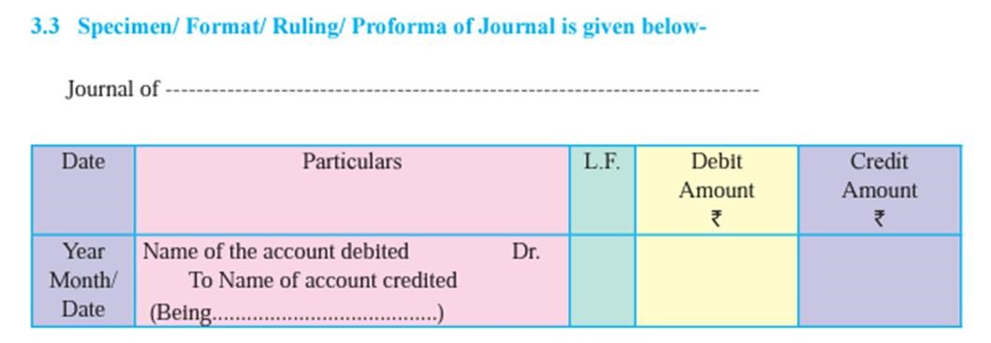

1.6 | Practical Problem
 | 

